Groups and activities in our Village

Bell-ringers

Weekly practice is normally between 19.30 and 21.00 on Mondays at St George's (Bicknoller) except on the 4th Monday of each month when we ring at West Quantoxhead (St Audries). If you are interested in learning to ring tower bells, or would like to see what bell-ringers do, you are very welcome to come along. Please contact Gary Sears, Tower Captain on
01984 656616 or 0777 545 0660: or email gary.sears@btinternet.com

The Bicknoller Lunch Club (Bic Lunches)
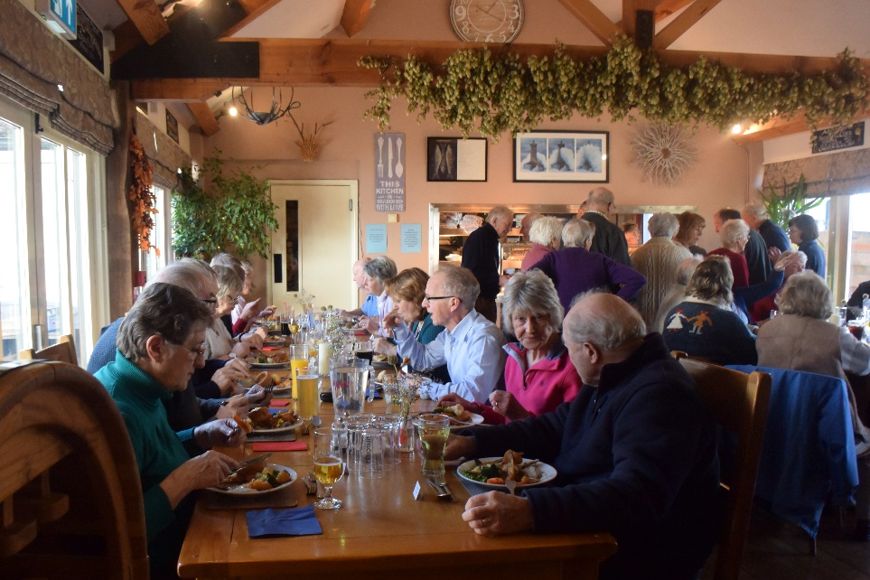
The original Bicknoller Lunch Club was set up by John Lees. He thought that as some people lived on their own and were not meeting many people, to have a monthly lunch time event where they would be able to mix with other people, and enjoy themselves at the same time, would be ideal.
As new people came in to the village they were also given the opportunity to come to this lunch time event.
Our licensees at the Bicknoller Inn, Chris and Rachel always serve us an enjoyable two course meal with tea or coffee to follow, and ending with a raffle for prizes.
It is usually held on the last Tuesday of the month (but this may vary) for the months of January to June, and September to November.

Co-ordinator and contact: Ann Leigh 01984 656575

Boules (Petanque) in Bicknoller
West Somerset has a thriving Boules League consisting of three divisions, each of which has about 8 teams. Locations are usually pub based and are spread between Bishops Lydeard and Minehead.
Bicknoller has two teams, Blues and Reds, both based at the Bicknoller Inn.
The boules season, which consists of a mix of league and cup matches, begins at the end of April and lasts until early September. Matches are usually played on a Wednesday evening (7:00pm) although some knockout competitions are held at a weekend.
We are currently oversubscribed but for more information please contact Phil Milton on 656296.

The Church: St. George’s, Bicknoller, and the Quantock Towers Benefice
You’ll find everything about the church, the people, the services and other activities in “Pathways”, the monthly magazine for the seven parishes in the Quantock Towers Benefice. A copy is included with this pack. Be sure of a very warm welcome from our Rector, Angela Berners-Wilson, her whole team and the congregation.
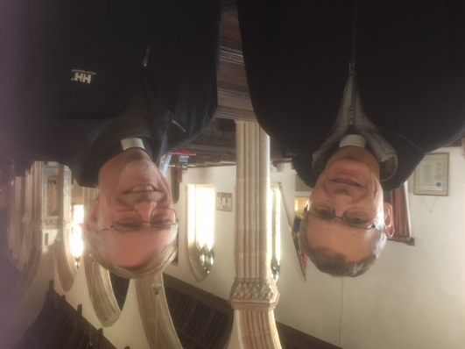
Rev. Angela Berners-Wilson Revs. Jon Rose (l) and Ben Flenley (r)

Bicklifts Community Transport Scheme
Bicklifts has been operating for 19 years and serves Bicknoller and other neighbouring villages and hamlets. Register as a passenger and one of your neighbours will drive you to wherever you wish to go, wait if a reasonable time and then bring you home. A community ‘not for profit’ group, Bicklifts is also a member of The West Somerset Community Car Scheme Partnership, and a Somerset Travel Pass entitles you to a 50% reduction up to £5 maximum when travelling after 9.30a.m. To join and book, ring David or Lucy Croxton on 01984 656489.
Bicknoller Defibrillators
Bicknoller has available, 24/7, two Automatic External Defibrillators (AED). One is located at the entrance of the Village Hall in Dashwoods Lane and the other is located in the old telephone box in Church Lane, opposite the Pub. Remember if you suspect anyone of having a heart attack, dial 999 for an ambulance. The AED’s in Bicknoller are registered with the South Western Ambulance Service.
If you require any information, contact John Grellier: kjgrellier@sky.com
01984 656799 or 07745 609174

Garden Visits
“I organise a couple of full day trips to interesting gardens, by coach or mini bus, and several shorter visits, usually using shared cars, during the summer. Most full day trips will be on Thursdays, but the shorter visits could be anytime”. Contact Sally Simpson, 01984 656266.

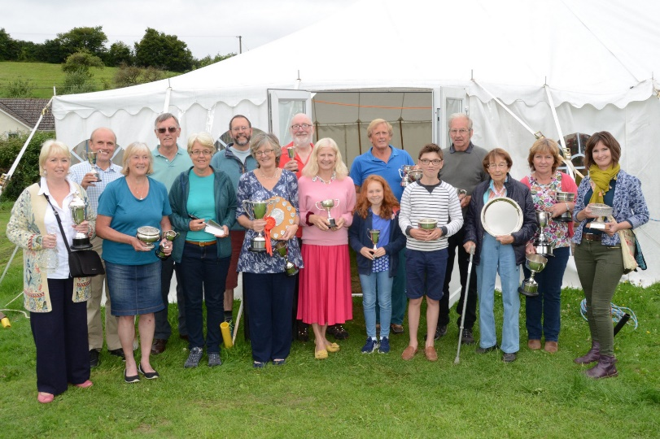
Bicknoller Flower Show
Bicknoller Flower Show presents two shows a year. Here is a picture of our own marquee, and the trophy winners in July 2017.
The Spring Show in March is a wonderful display of daffodils, other spring flowers and shrubs with floral art classes for 4 trophies. For good measure there’s a bake-off competition as well!

BFS also has two talks during the year, a fundraising hog roast with music and an AGM with refreshments and entertainment.
Membership costs only £3 a year, but if you wish, you can donate £5 or over, and become a patron with a mention in the summer show schedule. Members get free entry to the benches at the two shows, and priority when reserving tickets for any event or outing.
Happy gardening and let’s grow more to eat and to enjoy in Bicknoller.
Contact: Secretary Carole Darke 01984 656222

Macmillan Cancer Support
Bicknoller and Macmillan have been linked for 29 years due to the fact that the local fundraising committee, The Coleridge Committee, has its base here. Named after a Bicknoller resident, Julia Coleridge of White’s Meadow, who was a Macmillan volunteer for many years until she died, the committee raises funds across the rural area between Minehead and Bridgwater with most of its events taking place either in Bicknoller or one of the nearby villages.
The main fundraising event is the “Annual Garden Fete” which takes place on Bank Holiday Saturday in the garden of Old Orchard, Trendle Lane, Bicknoller – the home of Maggie Pumphrey, Chairman of the Committee. Around 40 volunteers are needed each year and these volunteers are mainly people who live in Bicknoller. This event raises around £4,000 each year and is great fun for all who are involved as well as the visitors.
With a committee of 12 people, 5 of whom live in Bicknoller, there is always a need for volunteers to help with events and anyone interested in doing so may contact Maggie on 01984 656394 or Clive Raisey (Treasurer) on 01984 656124. They will be very pleased to hear from you.

Mothers Union
Details of the local activities of the Diocesan Mothers’ Union will be found in “Pathways” (copy included with this pack). The contacts in Bicknoller are Molly Farmer (01984 656486) or Eileen Toal (01984 656431)

Pilates
Nathan Pirt
Pilates
Bicknoller Village Hall
Wednesday 9:00 am and 10:30am

For more information and to reserve your place, please contact Nathan on 07762 721271 or nathanpirt@icloud.com

Red Cross Open Gardens
A small number of gardens in the village are open every alternate year in aid of the British Red Cross. The actual gardens may vary, according to how owners feel, though it is usually best to have gardens which are in easy walking distance of the village hall, where lunches and teas are served, and where plant and produce stalls do a good trade. The Red Cross is a most worthy cause, but of course it is possible to do a similar opening for other charities; but owners usually find that one opening every other year is enough! Publicity, catering etc are handled by a small and hard working committee. Contact: Marian Greswell 01984 656285.

Bicknoller Social Club
Come and join us! For £15 annual membership, we present 9 interesting ‘talks’ and a couple of parties or outings each year!
We meet in the Village Hall at 2.30p.m.on a Wednesday afternoon, usually the third one of the month.
Topics coming up include ‘Thatching’, The West Somerset Railway and The Wonderful World of Glass. Yes something for everyone!
Enjoy the speaker, chat with friends and enjoy a cup of tea!
Contact: Marian Greswell, 01984 656285

Somerset Playford Group (at Bicknoller Village Hall)
Historical and traditional dancing in the style of dances collected by John Playford in the 17th Century. Last Wednesday of every month except July, August and December. Some knowledge of folk dancing would be helpful.
Contact: Avriel Allen, 01984 656672.

Bicknoller Parish Volunteer Group

Bicknoller parish is no different from other rural communities. It needs maintenance to keep things tidy and running smoothly. Leaves pile up, brambles spread, drains and culverts get blocked, and litter surreptitiously gets dropped.

If you'd like to volunteer to join this friendly group, give the coordinator John Grellier a call (kjgrellier@sky.com - 01984 656799 or 07745 609174). No matter what your ability, your help will be most welcome.
Bicknoller Table-Tennis Club
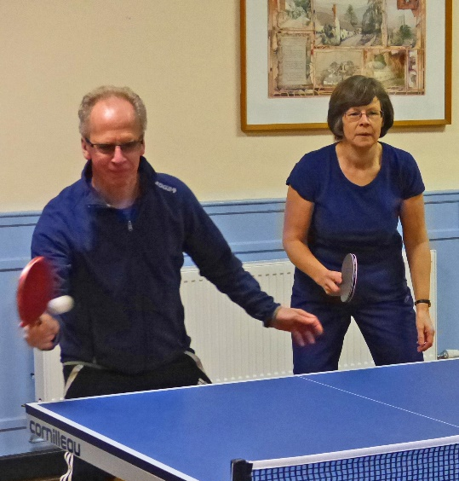
The Club meets most Mondays and Thursdays from 10.00 to 12.30, with a break at about 11.00 for tea/coffee and a natter. The Club is not a member of any league, and our members are of 'mixed ability'.
Unfortunately, as the Village Hall only has room for two tables, we have to limit ourselves to a maximum of sixteen members, though we try to show some flexibility. For example, when a vacancy arises we may accept, say, a husband and wife, temporarily taking us up to seventeen members. If the Club is 'full', prospective members can ask to be put on a waiting list.
New members should be aged eighteen or over (we are a playing club, not a training club) but again we exercise some flexibility. For example, a capable sixteen-year old might well be an asset to the Club and could apply to become a member.
New members must reside within the parish, but yet again we are flexible. For example, if an existing member moves locally he/she is welcome to remain a member, and if no parishioners ask to join, we may accept, say, a Watchet parishioner as a member, in order to make up numbers.
The Club does not have a formal structure. Anyone interested in joining the Club, should speak to, or email, the contact shown below. The contact maintains the Waiting List and keeps current members informed of new applications.
Contact - Keith Cook on 01984 656766 or at linndhu@hotmail.com

Bicknoller Village Hall

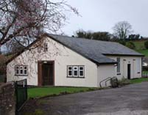
The Village Hall offers a large main hall with stage, a committee room and a kitchen. It has disabled access and toilet. Outside there is a large parking area, a recreational field and a children’s playground (re-equipped in 2017).
Contact for enquiries and bookings -
Sarah Williams – 01984 656400
See also www.bicknollervillagehall.org.

Bicknoller Women’s Institute

Ladies, how about having some time just for yourself?
Leave your cares and worries behind and come and enjoy a monthly evening as a member of Bicknoller Women’s Institute. Not jam and Jerusalem but fun, friendship and challenge.
We meet on the second Thursday of each month, except August, at 7.30pm at Bicknoller Village Hall.
Our programme is produced annually by members who put forward ideas for speakers and demonstrators. These are then shortlisted by a vote at our annual garden meeting. We aim for as much participation as possible at our meetings whether it is a craft session or a discussion.
For a copy of the programme contact one of the people below, or just come along to a meeting and give us a try. You will be made very welcome.
Contact: Mary Cox (Secretary) 01984 656224; Ann Leigh (Treasurer) 01984 656575 or Maggie Pumphrey (President) 01984 656394.

Bicknoller Neighbourhood Watch

Bicknoller has an active and enthusiastic Neighbourhood Watch scheme which new residents are very much encouraged to join. We aim to help keep our parish safe by offering advice and acting as a conduit for information between Avon & Somerset Police and our members. We have a total of seven wardens, each co-ordinating a patch within the parish, the contact details for whom are to be found on the parish website. You will find further information in our own welcome letter which you should receive directly from your warden. The parish co-ordinator is Andrew Harrison on 01984 634498 and Email ap_harrison@yahoo.com

