The Bicknoller Inn
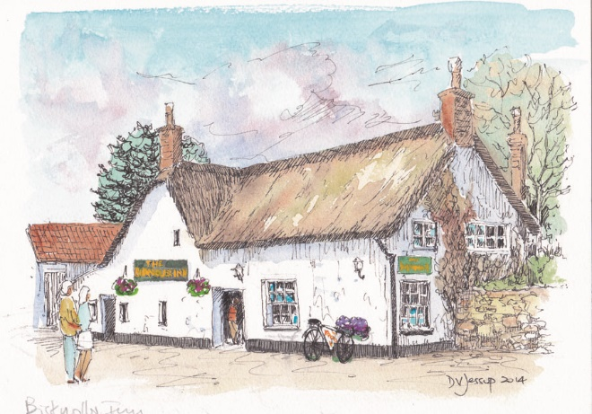

A warm welcome from Chris and Rachel
The Bicknoller Inn (or “The Bic” as it’s affectionately called) nestles at the foot of the Quantocks in an idyllic spot in this lovely village.
This historic thatched pub has the benefits of a traditional flag-stoned bar with a snug on the side along with an open plan dining area complete with log burner.
The pub is dog-friendly, attracting families, walkers and cyclists alike as it combines a lovely cobblestone courtyard, a large decking area and an extensive garden, with a Boules court on the side, plus an indoor skittles alley.
The menu is extensive and caters for all palates, from light bites to a full range of meal choices including vegetarian options and delicious puddings. Many of the dishes are homemade and all the products are sourced locally. Look out for our specials board.
Come and join us for our famous Sunday Carvery with a choice of two meats and seasonal vegetables, along with new & roast potatoes, not forgetting our wonderful caulicheese. Booking is advisable.
32 Church Lane, Bicknoller, TA4 4EL 01984 656284 www.thebicknollerinn.co.uk
9

